Name: ________________________ Study Guide Pre-Algebra

Date: _____________ Blk: 1 2 3 Final Exam Mrs. Theriot

I. Vocabulary – Know the definitions and be able to apply the skills associated with the words. Use the definitions from your old tests.

1) slope-

2) rise –

3) run –

4) coordinate plane-

5) direct variation –

6) function form –

7) y intercept-

8) parallel-

9) perpendicular-

10) quadrants –

11) function-

12) x intercept-

13) *** Study slope chart

14) system of equations-

15) point of intersection –

16) solution of a system –

17) domain –

18) range -

Review ALL notes.

**II. Chapter 4 practice problems:**

1) Plot and label the ordered pairs in a coordinate plane. (4.1)

A) (-4, 1) B) (0,2) C) ( -3, 0) D) (-1, -6)

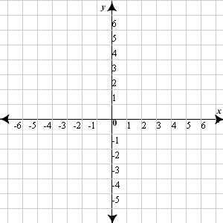

2) Without plotting the point, name the quadrant the point is in.

a) (6,8) ___ b) (-4, -15) ___

c) (5, -9) ____ d) (-3, 3) ___

e) (0, 2) ________ f) (2, 0) ________

3) Rewrite the equation in function form. (4.2)

a) 2x + y = 0 b) 5x – 2y = 20

c) -4x – 8y = 32 d) 2y = 3x – 4

4) Use the table method to graph the following equations. (4.2)



a) y = 2x – 6

b) 6x – 3y = 12



5) Graph the following equations. (4.3)

a) x = -5 b) y = 2





6) Graph the following equation using intercepts. (4.4)

4y – 8x = -16



7) Find the slope of a line passing through the following points. (4.5)

a) (1, -3), (-4,-5)

b) (0,-4), (5, -4)

8) Write a direct variation equation that relates x and y. (4.6)

a) x = 3 y = 9 b) x = 40 y = 8

9) Graph the following direct variation equations ( 4.6)

a) y = 3x b) y = -x





10) Rewrite the equations in slope intercept form. Then identify the slope and y intercept. (4.7)

a) y – 4 = 3x b) x = -y + 2 c) 2x + y = 6

d) 5x + 8y = 32 e) -6x – 3y = 24 f) 3y = 5x + 6

11) Graph the following equations using slope intercept form. (4.7)

Solve for y first. Identify m and b. Then graph.



a) 2x + 4y = 8



b) -5x + y = 4

12) Determine whether the two lines are parallel, perpendicular or neither.

a) y = -7x + 3 and y – 7x = 10

b) 4x – 8y + 6 = 0 and -12x + 6y = 2

13) What is the slope of a line parallel/ perpendicular to the given line?

a) y = 2x – 1 b) y = x + 2

Parallel: Parallel:

Perpendicular: Perpendicular:

c) 2y = 6x – 8

Parallel:

Perpendicular:

III. Distributive Property Review

14) 5 ( n + 3) 15) (2p + 6) 3 16) - ( 4 – 2x) 17) -5 ( a + 2)

IV. Solve Equations.

18) 5y + 8 = -2 19) 4x – 8 + x = 2 20) 10 ( z – 2 ) = 1 + 4 21) 14d – 6 = 17d

V. Decide whether the given ordered pair is a solution of the equation.

22) - 3x + 6y = 12, ( -4, 0) 23) x + 5y = 11, ( 2, 1)

VI. Graph linear equations or inequalities.

24) y = 3 25) x > -5 26) 5x + y < 4 27) 2y = 6x – 8

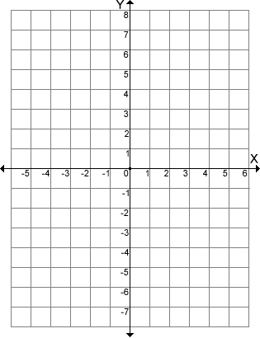

VII. Find the slope of a line passing through the points.

28) ( -4, 0) (-4, 3) 29) (4, 9) (1, 6)

VIII. Is the relationship a function? If so state the Domain and Range.

30) Input Output 31) Input Output 32) Input Output

2 1 1 1 1

4 3 2 4 2 4

5 3 9 3 6

8 7 4 16 4 8

IX. Write an equation of the line in slope-intercept form.

33) slope is -2; y-intercept is 5 34) slope is 1; y-intercept is -4 35) slope is 0; y-intercept is 2

X. Write the equation of the line in slope-intercept form.

36) 37) 38)

XI. Write an equation in slope-intercept form of the line that passes through the points

39) (4,9) ( 1, 6) 40) (0,7) ( 1, -1)

XII. Graph the inequality on a number line.

41)  42)  43)  44) x >-3 45) 7 < x

XIII. Solve the inequality.

46) x – 5 < -9 47)  48) -5x > 35 49) 5x + 1 > 2x + 13

XIV. Graph linear inequalities.

50) y < 3 51) x > -5 52) 5x + y < 4 53) -2y < 6x – 8



XV. 54. Is the ordered pair (5,2) a solution to the system below? (7.1)

3x – 2y = 11

-x + 6y = 7

XVI. Solve the system by graphing. Check your solution. (7.1) Graph the system of inequalities

55) y= -x + 5 56) 2x – y = 2 57) 2x + y = 2 58) y < ½ x + 2

y = x + 1 x = 4 x –y = 4 y > 3x - 3



Ck: Ck: Ck:

XVII. Solve the system by substitution.

|  |  |
| --- | --- |
| 59) x + y = 1  2x – 3y = 12 | 60) x + 2y = - 5  4x – 3y = 2 |

XVIII. Solve the system by using linear combinations (elimination method).

|  |  |  |
| --- | --- | --- |
| 61) 4x – 3y = 9  x + 3y = 6 | 62) x + y = 1  2x – 3y = 12 | 63) 6x + 5y = 10  6x – 2y = 3 |

**Sign and return 2nd 9 weeks tests on the day of your exam to earn bonus points!!!!**

OLD TEST PAPERS are the best study guides