Name

ClassDate



9-7

**Practice**

Linear, Quadratic, and Exponential Models

*Form G*

**Graph each set of points. Which model is most appropriate for each set?**

**1.** (–3, –8), (–1, –2), (0, 1), (1, 4), (3, 10) **2.** (–2, 0.75), (–1, 1.5), (0, 3), (1, 6)

**3.** (–2, 1), (–1, 0), (0, 1), (1, 4), (2, 9) **4.** (–2, –11), (–1, –5), (0, –3), (1, –5), (2, –11)

**5.** (–4, 0), (–2, –1), (0, –2), (2, –3), (4, –4) **6.** (–1, –0.67), (0, –2), (1, –6), (2, –18)

**7.** (–3, 10), (–1, 2), (0, 1), (1, 2), (3, 10) **8.** (–2, 4), (–1, 2), (0, 0), (1, –2), (2, –4)

**Which type of function best models the data in each table? Use differences or ratios.**

**9. 10. 11.**

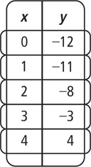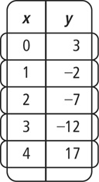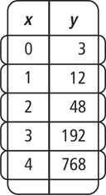

1. Which type of function best models the ordered pairs (–1, 6), (0, 1), (1, 2), and (2, 9)? Use differences or ratios.
2. Which type of function best models the ordered pairs (–1, –0.25), (0, –0.5), (1, –1), and (2, –2)? Use differences or ratios.

**Prentice Hall Gold Algebra 1 •** Teaching Resources

Copyright © by Pearson Education, Inc., or its affiliates. All Rights Reserved.

**63**

Name

Class

Date



Linear, Quadratic, and Exponential Models

9-7

**Practice** (continued)

*Form G*

**Which type of function best models the data in each table? Write an equation to model the data.**

**14.**

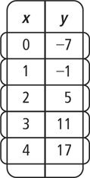

**15.**

**16.**

**17.**

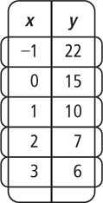

**18.**

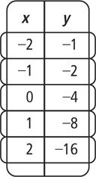

**19.**

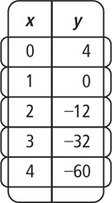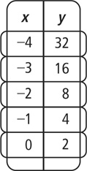

**Which type of function best models the data in each ordered pair? Write an equation to model the data.**

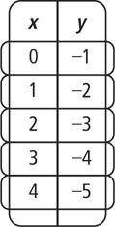

**20.** (–3, 33), (–1, 21), (0, 15), (1,9), (3, –3) **21.** (–2, –16), (–1, –8), (0, –4), (1, –2), (2, –1)

**22.** (–2,), (–1,), (0, ), (1, 1), (2, 3) **23.** (–2, –2), (–1, –3.5), (0, –4), (1, –3.5), (2, –2)

**24.** (–6, 5), (–3, 4.5), (0, 4), (3, 3.5), (6, 3) **25.** (–1, 10), (0, 3), (1, 0), (2, 1)

1. The population of a city for years since 2000 is shown below. Which kind of function best models the data? Write an equation to model the data.

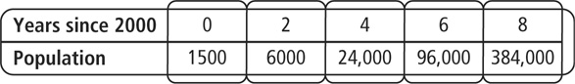

**Prentice Hall Gold Algebra 1 •** Teaching Resources

Copyright © by Pearson Education, Inc., or its affiliates. All Rights Reserved.

**64**